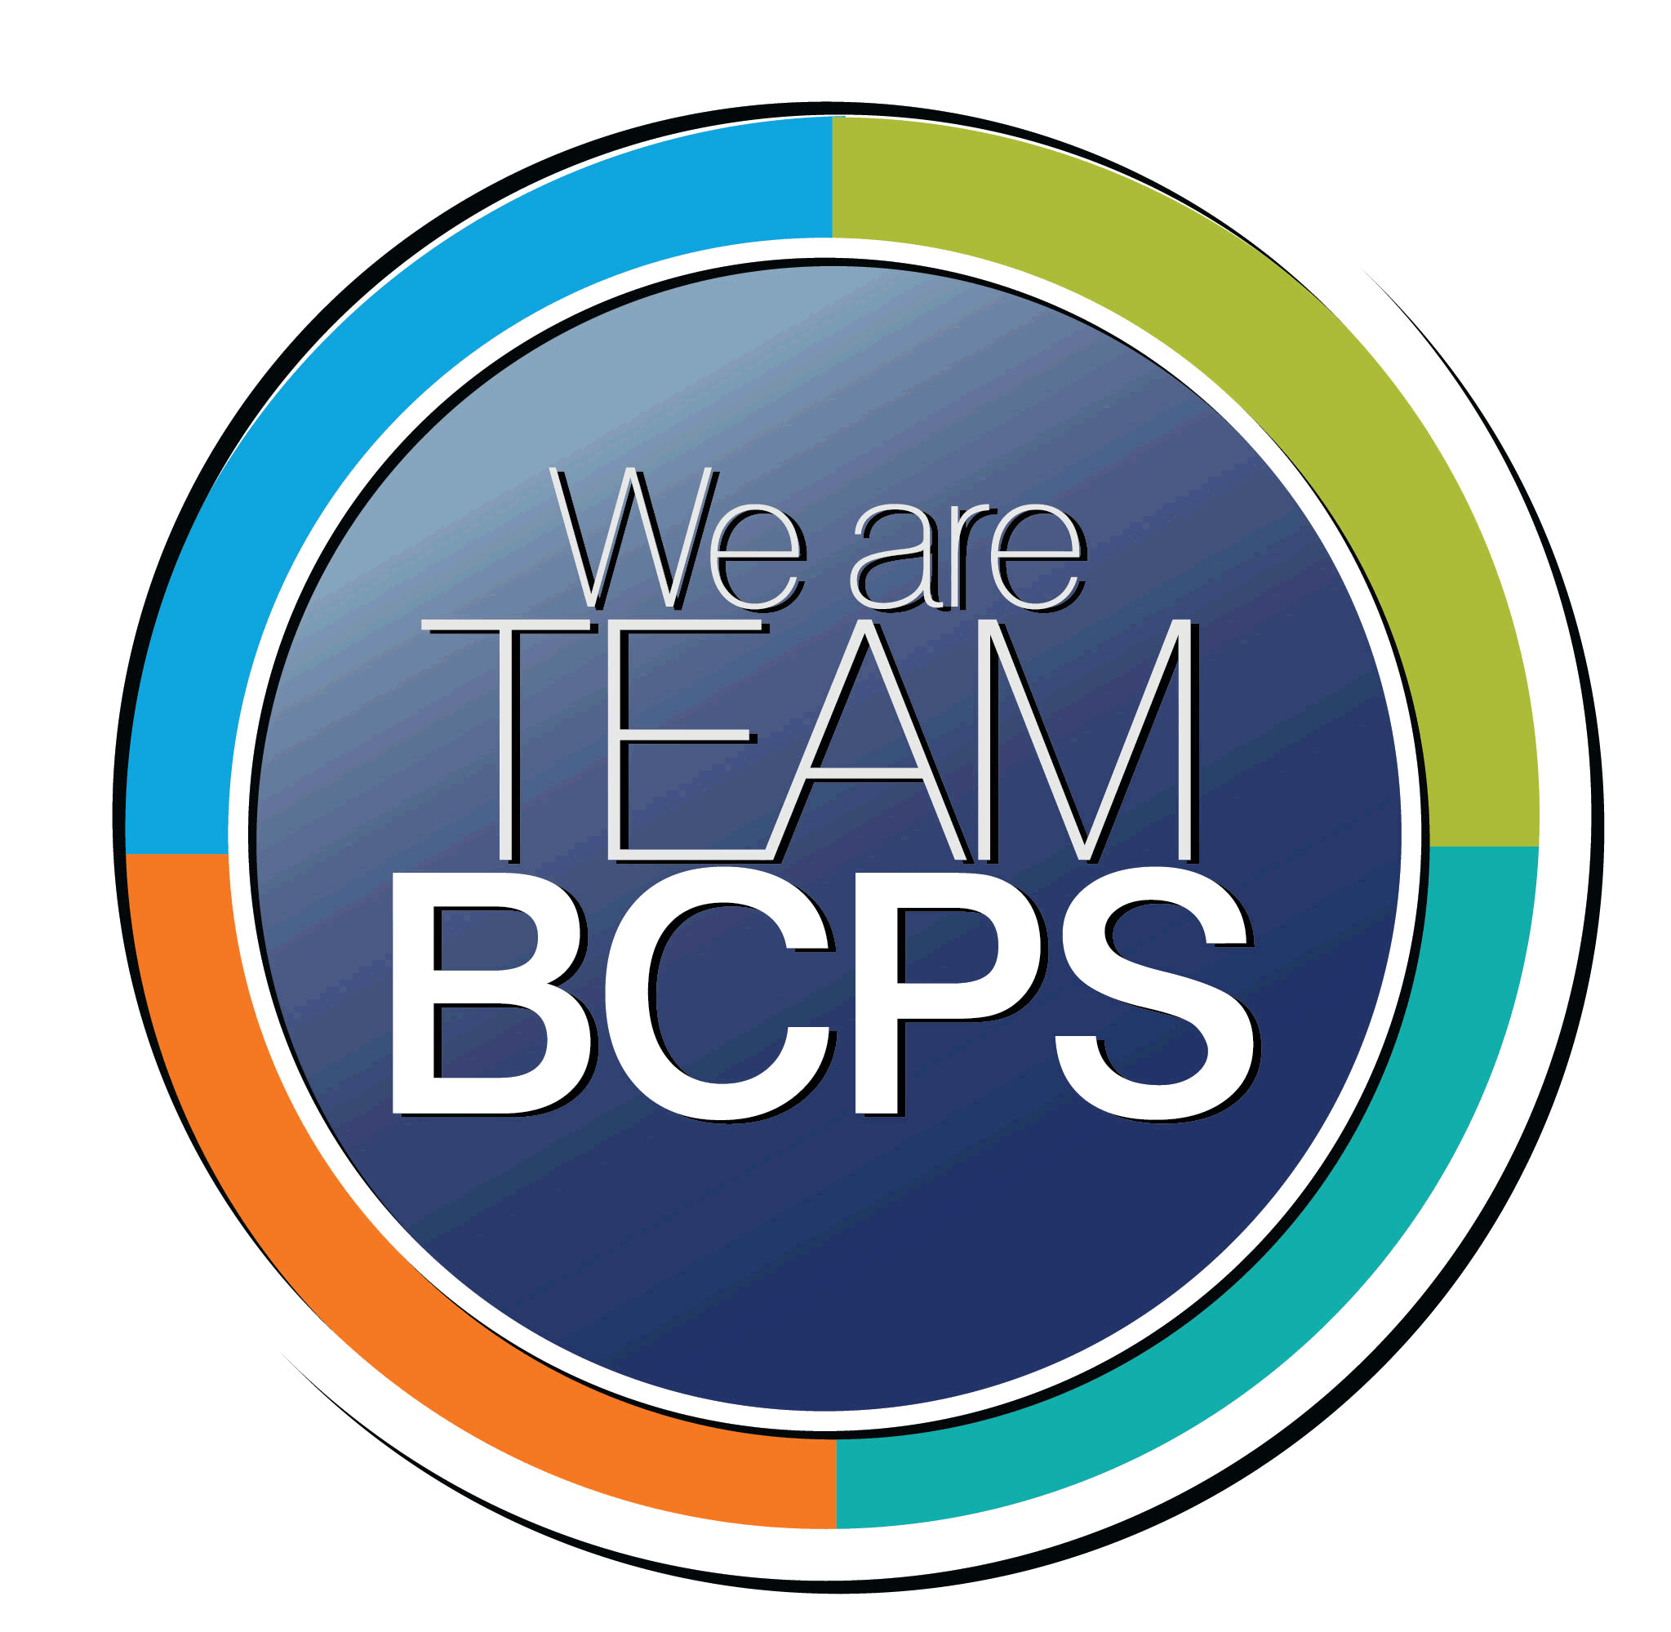 Schoolwide Positive Behavior Plan
Baltimore County Public Schools

Date Completed: 8/1/2022 School Year 2022-2023
School: Middlesex ES

Section 1: Initial Steps
School Climate Team
Identify members of a School Climate Team (consider a representative selection of members). The team meets initially to examine equity concerns and data and to develop the Schoolwide Positive Behavior Plan. The team should then meet monthly (minimum quarterly) to assess the effectiveness of the SWPBP on an ongoing basis.
David Frank
Jennifer Handshoe
Carly Davis
Terrance Thomas
Kim Einolf

Equity Lens
Through an equity lens, identify what the data indicate about the social-emotional needs of students and the support provided by staff members relative to disproportionality between student groups, especially for African Americans or students receiving special education. Also consider the school’s population with regard to ELL, Latinx, and/or other student groups. (Information may be from School Data Story)
Attendance Data
Student Surveys
Staff Surveys
Student Referral Data

Data Analysis
Summarize what the data tell about the school climate. (Information from School Data Story)
School’s suspensions data is not statistically relevant due to low number of incidents

Climate Goals
Identify the school’s goals in improving the social-emotional climate of the building. (Information from School Progress Plan)
Classroom routines and expectations promote cooperative learning, teacher to student interactions and student to student interactions characterized by mutual respect and caring.
Educators will examine and interrogate their personal biases to become aware of the ways in which their own cultural experiences influence the conditions and learning opportunities that they create for students.

Section 2: Developing and Teaching Expectations
Expectations Defined
Identify a School Code of Conduct with 3-5 positively stated school expectations. Develop a way to communicate the identified rules, based on the schoolwide expectations, for specific settings within the school building. Expectations should be clearly stated, communicated, taught, and frequently referenced.
I will be helpful to myself and others.
I work towards excellence as I learn.
I will be resilient when things to do not go my way.
I will be orderly with my space and actions.

Students will be introduced to the HERO expectations in morning meeting and they will be reviewed daily in the morning announcements. Each student will have a HERO journal for recording their progress towards the code of conduct and reflections to be shared with teachers. Each classroom has the code of conduct posted so it can be easily referenced during the day.

Classroom Plan for Teaching and Reinforcing Expectations, Routines, and Procedures
Teachers develop visuals to communicate culturally relevant classroom expectations, routines, and procedures based upon the schoolwide expectations. Educators explicitly teach expectations, routines, and procedures. The school staff recognize and reinforce expected and positive behavior. Teachers identify encouraging procedures and corrective procedures for their classrooms.
Conscience Discipline
Virtue Language
Restorative Practices
Counseling guidance lessons
Morning Announcements
Fun Friday
HERO journals

Family/Community Engagement
Identify how the Schoolwide Positive Behavior Plan, the schoolwide expectations, and/or interventions will be communicated and shared with families. Consider how to include family and student voice in the initial plan and in evaluating the plan throughout the year.
Information will be shared via the student handbook, Schoology Parent Group, monthly newsletters (emailed and posted to the website).
Utilize community school resources

Section 3: Developing Interventions and Supporting Students
Resource Mapping of MTSS
Identify the evidence-based practices and interventions offered at Tier 1, Tier 2, and Tier 3 to support all students. Consider what culturally responsive interventions the school requires to meet the specific needs of the students.
Tier1-
School Wide Code of Conduct
Positive Relationships with ALL students
SEL Curriculum (virtues)
Virtue Assemblies
Conscious Discipline routines/procedures
Morning announcements (modeling SEL practices/mindfulness)
Proactive Classroom Management
Progressive Response to Problem Behaviors
HIT time
MTSS (special area)
Tier 2-
Behavior Contracts
Self-Monitoring
Mentors
Differentiated Reinforcement
Small Group SEL instruction or Social Skills instruction
Counseling small groups
Tier 3-
FBA-based Behavior Intervention Plan
Replacement Behavior Training
Cognitive Behavioral Counseling/Therapy
PCM trained staff
LSCI trained staff
Individual counseling
Outside agency referral

Social-Emotional Learning
Identify the specific evidence-based social-emotional learning skill development practices the school will implement during the school year. Consider the importance of trauma-informed care, mental health awareness, level of students’ coping skills, etc. Determine how the social-emotional learning and the SEL competencies will be integrated into the school’s programming. Consider the need for any training the staff members may require.
3 Signature SEL practices (welcoming ritual, engaging practices, optimistic closure) will be used across grade level in every classroom daily.
Every faculty meeting with model the 3 signature SEL practices for teachers and staff
PCM training for any identified staff as available by BCPS

Character Education
Determine how specific evidence-based character education learning will be infused into the school’s programming to promote positive behavior and ethical decision-making. Character education will be culturally responsive and co-created with diverse stakeholders. Consider the need for any training the staff members may require.
Virtue Assemblies will be completed monthly.
Counseling guidance lessons
Daily Announcements

Professional Development for Staff
Identify the professional development that will be offered to staff members throughout the year in order to support their knowledge, skill development, and implementation of the interventions selected, the character education learning, and social-emotional learning practices. Specify the schedule for professional development and how to obtain teacher feedback during the year to address their concerns and areas in which they want/need more information. (Information from School Progress Plan.)
Faculty Meetings focusing on SEL Practices
Think Tank
Attendance Meetings
Weekly behavior team meetings

Section 4: Supporting and Responding to Student Behavior
Recognitions/Incentives
Identify a variety of positive consequences, acknowledgements, recognitions, and/or incentives that are linked to the behavioral expectations and rules. Develop a system for implementing the positive acknowledgements consistently in school settings. Consider how to monitor who is being recognized and who is not being recognized and whether explicit or implicit biases may be occurring.
HERO Chart
Fun Friday
Student of the month
Recognition in Daily Announcements

Hierarchy for Behavioral Referrals and Consequences
Identify the behaviors that are teacher-managed, behaviors referred to resource staff, and behaviors referred to administration. Refer to the BCPS Student Handbook for teacher and administrator-led interventions. Consider how unsafe behaviors will be addressed.
Teacher managed behaviors include: calling out, classroom disruption, refusal to follow a reasonable request, failure to complete work, failure to serve detention, verbal put downs, inappropriate use of electronic, academic dishonesty, horseplay/minor physical contact, inappropriate utterances/comments, forgery of school docs.

Resource staff managed behavior: Fighting/aggressive physical contact, threats, leaving designated location, not with class during emergency, obscene/foul language directed at student/staff, bullying/harassment of student/staff, repeated teacher managed behaviors.
Teachers will complete the online referral form for all non-classroom managed behaviors. The office will be responsible for entering this information into FOCUS.

Behaviors referred to administration include: fighting/aggressive physical contact, weapons/drugs/alcohol, bullying/harassment, sexual harassment and any category 3 offense
Behaviors referred to administration include: fighting/aggressive physical contact

Unsafe behaviors – teachers will call on the walkie for immediate support, teacher will relocate the class to the hallway if behavior threatens the safety of others.

Response for Intensive Behaviors
Identify a hierarchy of responses to intensive behaviors (i.e., emergency/crisis management/threat assessment/unsafe behaviors) including interventions and supports. Indicate which school staff members will respond as well as procedures and training as needed.
Mr Thomas -SEL Teacher
Ms. Handshoe – SEL Teacher
Ms. Collins
Mr. Frank
Ms. Davis
Ms. Einolf
Admin

Threat assessments - School Counselor Davis or SSW Einolf will respond to threat assessments and conduct a threat assessment to determine the next steps, parent will be notified and based on the level of the threat will come in to meet with the school counselor, if necessary, a referral will be made to an outside agency for support and parents will sign a release of information for the outside agency and school to communicate. Threat assessment form will be completed and shared with the Threat Management Office. A meeting will be scheduled with the Threat Management Team to discuss what occurred and a plan will be developed to ensure the safety of the student to include check-in/check out with a trusted adult.

Monitoring the Schoolwide Positive Behavior Plan/Data Analysis
Identify the data that will be collected and reviewed by the School Climate Team in order to identify behavior trends, patterns, action steps, and interventions using a problem-solving strategy. Consider having a uniform referral form for staff to complete to document referrals to administration. Consider how teachers should document classroom-managed concerns/behaviors/difficulties. (Information from School Progress Plan.)
HERO Chart
Referral data
Positive classroom climate checklist data
Attendance data
Online referral form
Quarterly student and staff surveys
Weekly behavioral meetings

Section 5: Miscellaneous Content/Components

